Name: Class: Mark:

1. Draw a flowchart for a program which asks the user to enter a password. If the user enters “HiThere!” then print “Welcome”, and then end the program.
If they enter a different password, print “Wrong password” and end the program. [4]

2. An algorithm is to be written which calculates the average of a set of student marks entered. If -1 is entered, then the program ends. The flowchart on the next page describes the steps in the algorithm. However, most of the stages have been omitted.
(a) Complete the flowchart, using the item number from the list of
items given below. [6]
Item number | Item description
1 | Is mark = -1?
2 | INPUT "Enter next mark"
3 | OUTPUT "No marks entered"
4 | INPUT mark
5 | count count + 1
6 | OUTPUT average
7 | total 0
8 | Is count 0?
9 | total total + mark
10 | average total / count

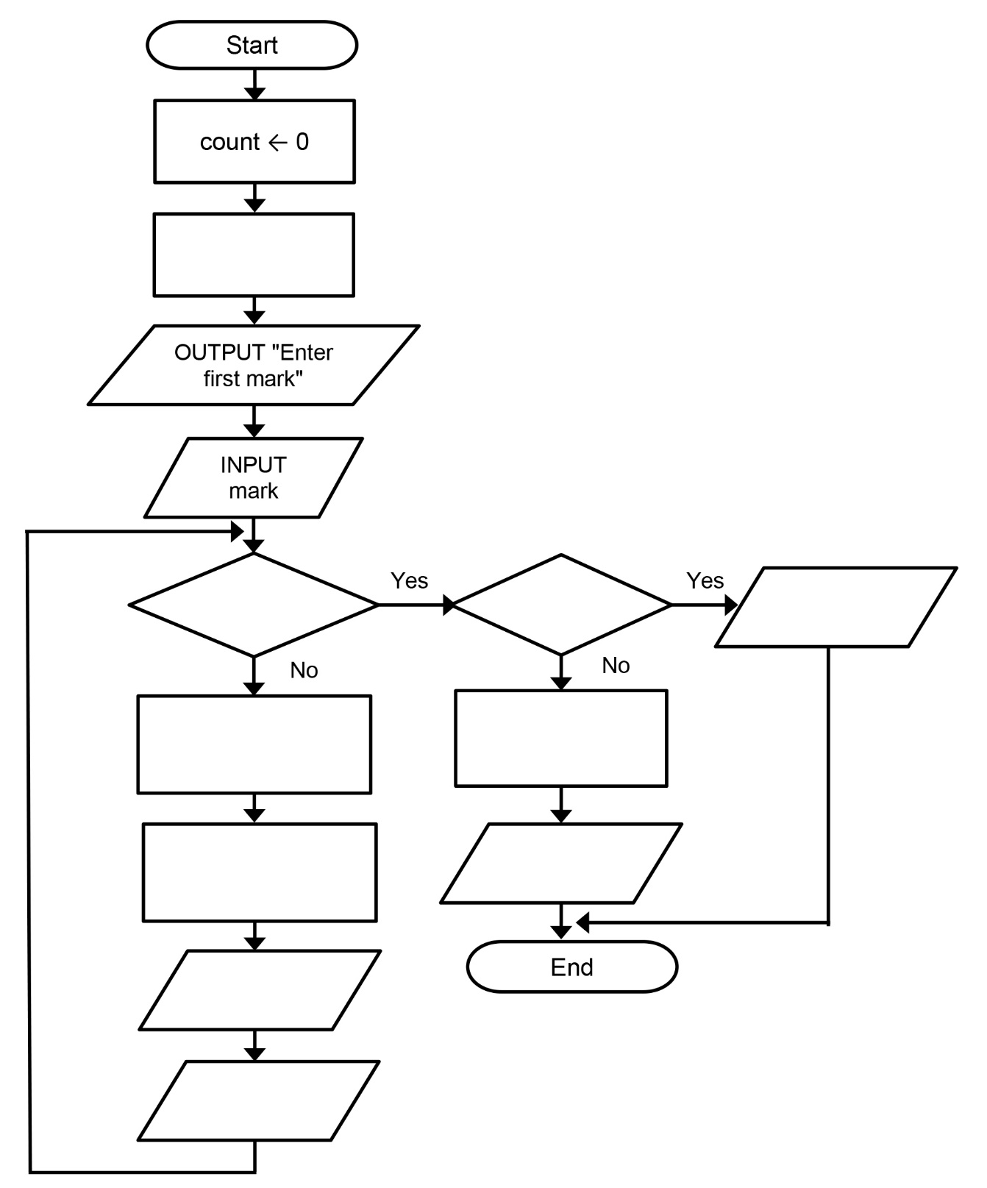
[Total 10 marks]

